Ideation Phase
Brainstorm & Idea Prioritization Template

Date | 01 November 2025
Team ID | NM2025TMID09058
Project Name | Optimizing User, Group, and Role Management  with Access Control and Workflows
Maximum Marks | 4 Marks

Brainstorm & Idea Prioritization Template:
Brainstorming creates an open and inclusive environment that encourages every team member to actively engage in the creative thinking process leading to problem-solving. By focusing on quantity over quality, it welcomes out-of-the-box ideas that can be expanded and refined. Participants are motivated to collaborate and support one another, fostering the development of a wide range of innovative solutions.

Step 1: Team Gathering, Collaboration, and Selecting the Problem Statement
Our team identified a recurring challenge faced by many organizations: as they expand, managing users, groups, and roles becomes increasingly complex. Manual role assignments, inconsistent access permissions, and the absence of centralized monitoring frequently result in inefficiencies and potential security vulnerabilities.
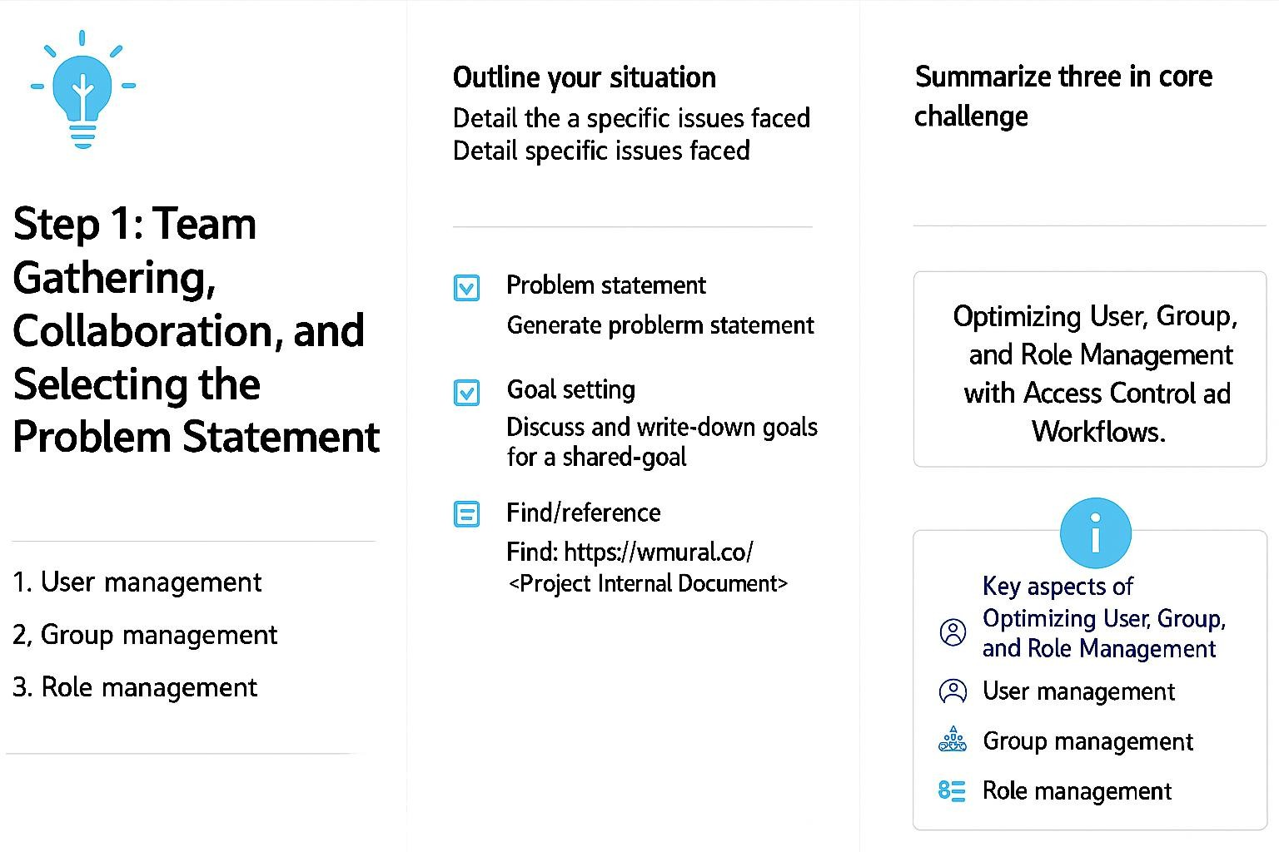
This project aims to simplify and automate user management processes within ServiceNow. The solution ensures that users receive appropriate access according to their roles, automates approval workflows for access requests, and strengthens overall security by providing improved visibility and control.

.
Step 2: Brainstorm, Idea Listing, and Grouping
Our team conducted a brainstorming session to explore ways to enhance user, group, and role management in ServiceNow. We discussed various ideas and categorized them based on three key factors: security, efficiency, and ease of implementation.
Key ideas:
● A centralized module for managing users, groups, and roles
● Automated workflows for role assignments
● Approval-based access request system
● Access Control Lists (ACLs) to ensure data security
● Role-based dashboards and reporting features
● Audit trails and notifications to track access-related activities

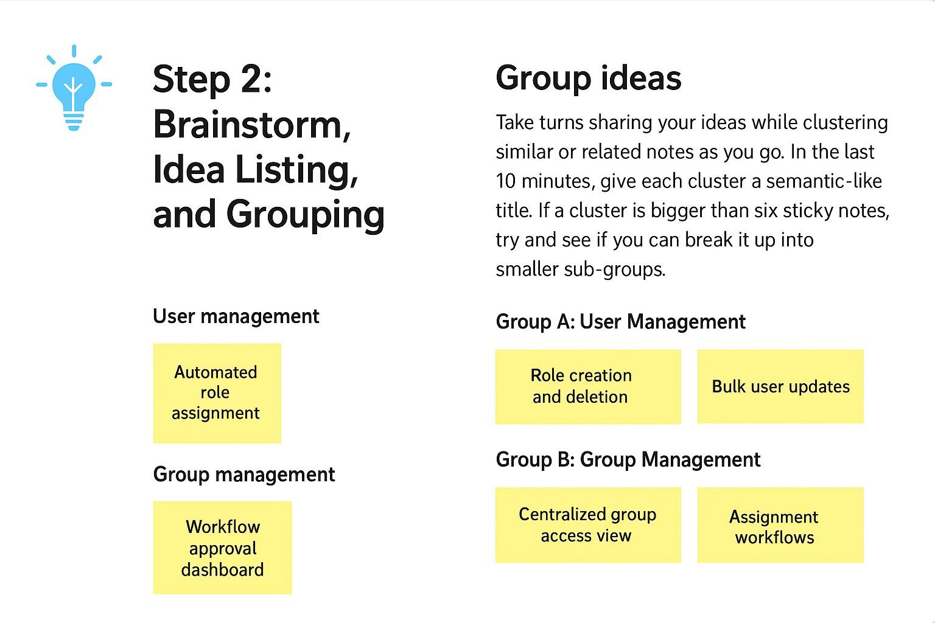
Step 3: Idea Prioritization
After evaluating all the ideas through an impact-versus-feasibility analysis, we chose the most valuable and practical features for implementation.
Prioritized ideas:
- Centralized portal for managing users and roles
- Automated workflows for role assignments
- Access Control List (ACL) configuration for secure data management
- Approval workflows to manage access requests
- Audit logs and real-time notifications for activity tracking

